
Disaster Relief Resource Allocation System Using Priority Queue and Graph
A CAPSTONE PROJECT REPORT

A Capstone Project Report submitted in partial fulfilment of the requirements for the Course of

CSA0312 DATA STRUCTURE

to the award of the degree of

BACHELOR OF ENGINEERING/BACHELOR OF TECHNOLOGY
IN
INFORMATION TECHNOLOGY,COMPUTER SCIENCE ENGINEERING
Submitted by
Suriya Priya k (192521195 )
Nivya Manasa (192511225)
Kalaiyarasi (192571076)
Under the Supervision of
Dr. Kalaiarasi

SIMATS ENGINEERING
Saveetha Institute of Medical and Technical Sciences
Chennai-602105
SEPTEMBER 2026
BONAFIDE CERTIFICATE

This is to certify that the Capstone Project entitled “Disaster Relief Resource Allocation System Using Priority Queue And Graph” has been carried out by Suriya Priya K (192521195),Nivya Manasa (192511225) and Kalaiyarasi (192571076) under the supervision of Dr. Kalaiarasi and is submitted in partial fulfilment of the requirements for the current semester of the B. Tech Information Technology and Computer Science engineering program at Saveetha Institute of Medical and Technical Sciences, Chennai.

COURSE COORDINATOR COURSE FACULTY
DR. R. KRITHIKA DR. S. KALAIARASI
ASSOCIATE PROFESSOR ASSOCIATE PROFESSOR
SIMATS Engineering, SIMATS Engineering
SIMATS Chennai-602105 SIMATS Engineering -602105

DECLARATION

We, Suriya Priya. K, Nivya Manasa. S and Kalaiyarasi. D of the IT AND CSE SIMATS Engineering, Saveetha Institute of Medical and Technical Sciences, Chennai, hereby declare that the Capstone Project Work entitled “Disaster Relief Resource Allocation System Using Priority Queue And Graph” is the result of our own bonafide efforts. To the best of our knowledge, the work presented herein is original, accurate, and has been carried out in accordance with the principles of engineering ethics and academic integrity. All sources, references, data, and other materials used in the project have been appropriately acknowledged. We further declare that the data, results, analysis, and findings presented in this report have not been fabricated, falsified, or manipulated. Any external tools, software, datasets, computational resources, or AI-assisted tools used during the project have been appropriately disclosed. We confirm that all applicable ethical, academic, institutional, and professional requirements have been duly followed throughout the planning, execution, analysis, and documentation of the project.

Place: Chennai
Date:

Signature of the Students with Names
Suriya Priya. K (192521195)
Nivya Manasa. S (192511225)
Kalaiyarasi. D (192571076)

Individual Contribution Statement
(Mandatory for all team projects)

Student  Name /  Register No. | Specific Responsibilities | Design &  Development Contribution | Testing &  Analysis  Contribution | Report Contribution | Approx.  Contribution  (%)
Suriya Priya K | Developed the Admin/Rescue Management Module for managing emergency requests and rescue operations | Designed admin dashboard, emergency request management, priority queue, rescue team assignment, map visualization and shortest-path route calculation | Tested request prioritization, rescue team assignment, map display, Dijkstra’s shortest-path calculation and status updates | Contributed to Module 3 description, system design, implementation, testing and results sections | [__33.3%]
Nivya Manasa | Stranger/Helper reporting and emergency victim registration. | Designed helper interface, map location selection, photo upload and database integration | Tested location selection, image upload, report submission and data storage. | Module 2, implementation, testing and results | [__33.3%]
Kalaiyarasi D | Developed the Affected Person/User Module for submitting emergency assistance requests] | Designed user registration, login, “Need Help” option, GPS location capture and emergency request submission | Tested user registration, login, GPS permission, location capture and emergency request submission | Contributed to Module 1 description, system design, implementation, testing and results sections | [__33.4%]
Total |  |  |  |  | 100%

ABSTRACT

Natural disasters such as floods, earthquakes, cyclones, landslides, and other emergency situations can severely affect human life and infrastructure. During such disasters, relief organizations must distribute limited resources such as food, water, medicines, medical support, rescue teams, and emergency equipment to multiple affected locations. A major challenge is deciding which location should receive assistance first and identifying the most efficient route for delivering the resources.
The proposed Disaster Relief Resource Allocation System using Priority Queue and Graph is designed to address this problem using fundamental data structures and algorithms. The system represents disaster-affected locations and their connecting routes using a graph data structure. Each location is assigned a priority based on factors such as severity of the disaster, number of affected people, availability of essential resources, and emergency requirements. A priority queue is used to organize the affected locations so that areas with higher priority receive relief resources before lower-priority areas.
The graph structure enables the system to represent the road network between relief centers and affected locations. Shortest-path algorithms can be applied to identify efficient routes and reduce travel distance or response time. The priority queue ensures that urgent requests are processed systematically and dynamically. 1The proposed system provides an organized approach to disaster management by combining priority-based decision-making with graph-based route analysis. The implementation demonstrates how data structures can solve practical real-world problems involving emergency resource allocation. The system can improve response efficiency, reduce delays, and support better decision-making during disaster situations.
Keywords: Disaster Management, Priority Queue, Graph, Resource Allocation, Shortest Path, Emergency Response.

TABLE OF CONTENTS

Sl.  No | Title | Page  No
i | CERTIFICATE FROM THE SUPERVISOR | ii
ii | DECLARATION BY THE CANDIDATE | iii
Iii | INDIVIDUAL CONTRIBUTION STATEMENT | iv
iv | ABSTRACT | v
v | LIST OF FIGURES | vi
vi | LIST OF TABLES | vii
vii | LIST OF ABBREVIATIONS | viii
1 | CHAPTER 1: Introduction
2 | CHAPTER 2: Literature Review
3 | CHAPTER 3: Engineering Design & Trade-offs, Sustainability,  Ethics, Safety, Risk & Security
4 | CHAPTER 4: Implementation, Testing & Results, Project  Management
5 | CHAPTER 5: Conclusion & Reflection
 | References
 | Appendices

LIST OF FIGURES
Figure No. | Figure Name | Page No.
1 | Map | 23
2 | Rescue Area | 24
3 | Dashboard

LIST OF TABLES
Table No. | Table Name | Page No.
1 | Comparative analysis | 14
2 | Stakeholder requirement | 16
3 | Requirement function | 16
4 | Standard /code | 17
5 | Parameters | 17
6 | Criterion | 18
7 | Design Decision | 19
8 | Domian | 20
9 | Risk | 20
10 | Tool | 21
11 | Requirement | 22
12 | Objective | 24
13 | Project,Planning,Roles &Budget | 24

CHAPTER 1
INTRODUCTION AND ENGINEERING PROBLEM
1.1 Background

Disaster situations such as floods, earthquakes, cyclones, building collapses, and other emergencies can create multiple requests for assistance at the same time. During such situations, rescue teams need to identify critical cases quickly and determine an efficient route to reach affected people. The proposed Disaster Relief Resource Allocation System Using Priority Queue and Graph is a web-based system that connects affected people, public helpers, and rescue administrators through a common platform. In Module 3, the administrator acts as the rescue control center and monitors emergency requests received from the system. The module provides an interactive map to visualize the locations of affected people, organizes requests according to their priority, assigns available rescue teams, and determines suitable routes using graph-based shortest-path techniques. The combination of a Priority Queue, Graph, Dijkstra’s algorithm, database, GPS location data, and interactive mapping provides a technical foundation for improving emergency response and resource allocation

.1.2 Need for the Project

During disasters, emergency requests may arrive from several locations simultaneously, making manual identification and prioritization difficult. Rescue teams may waste valuable time if requests are handled without considering their severity or if inefficient routes are selected. The problem affects disaster victims who require immediate assistance as well as rescue teams responsible for responding to multiple incidents. Existing manual approaches may depend on phone calls, messages, static maps, or human decision-making, which can result in delays, incomplete location information, and inefficient resource utilization. From an engineering perspective, the problem involves real-time location handling, request prioritization, resource assignment, and route optimization. Therefore, a centralized web-based solution is required to help administrators visualize emergency locations, prioritize requests, select appropriate rescue resources, and identify efficient routes.

1.3 Problem Statement

During a disaster, multiple emergency requests can originate from different geographical locations with different levels of severity, while the number of available rescue teams and accessible routes may be limited. A rescue management system therefore needs to simultaneously handle emergency prioritization, geographical location identification, rescue-team availability, and route optimization. The engineering challenge is to develop a system that can receive and organize emergency requests using a priority-based mechanism, display affected locations on an interactive map, assign suitable rescue teams, and calculate an efficient route between the rescue team and the affected location using graph-based algorithms. The system must also operate within practical constraints such as limited rescue resources, changing request priorities, GPS accuracy, road-network representation, database availability, and response time.

1.4 Project Aim
The aim of this project is to develop a web-based disaster relief resource allocation system that enables rescue administrators to prioritize emergency requests, visualize affected locations, allocate available rescue teams, and determine efficient rescue routes using Priority Queue and Graph-based algorithms.
1.5 Project Objectives
- To design an administrator-based rescue management interface for monitoring disaster-related emergency requests.
- To develop an interactive map that displays the geographical locations of affected people received through the system.
- To implement a Priority Queue for arranging emergency requests according to their severity and urgency.
- To model the road network as a weighted graph consisting of locations and connecting routes.
- To implement Dijkstra’s shortest-path algorithm for identifying an efficient route between a rescue team and an affected location.
- To develop a rescue-team assignment mechanism based on request priority and team availability.
- To integrate the map, emergency database, priority mechanism, and routing algorithm into a single web-based rescue dashboard.
- To test the system using different emergency locations, priorities, rescue teams, and route conditions.
- To evaluate the effectiveness of the proposed system in reducing manual decision-making and improving rescue resource allocation

1.6 Scope

The scope of the project includes the development of an Admin or Rescue Management module capable of monitoring emergency requests through a web-based dashboard. The system includes an interactive map for displaying the locations of affected people, priority-based emergency request management, rescue-team assignment, Graph-based road representation, and shortest-path calculation using Dijkstra's algorithm. The database stores relevant information such as emergency requests, affected locations, priorities, rescue teams, and request statuses. The project does not include direct control of physical rescue vehicles, drones, traffic signals, or other emergency equipment. It also does not guarantee actual traffic conditions or real-time movement of rescue vehicles. The system assumes that the location information received from the user or selected by the stranger is sufficiently accurate and that rescue-team information is available in the database. The routing function is limited to the road or network information represented within the system, while GPS accuracy may vary depending on the device, network conditions, and surrounding environment.

1.7 Expected Engineering Outcome
The expected engineering outcome is a functional web-based rescue management prototype that acts as a centralized control system for disaster-response activities. The system will provide an interactive map through which the administrator can identify the locations of affected people and emergency reports. A Priority Queue will organize requests based on their urgency, while the Graph model will represent the available road network. Dijkstra's algorithm will be used to calculate an efficient path between a rescue team and the selected emergency location. The final prototype is expected to demonstrate the practical application of data structures, algorithms, database technology, GPS-based location services, and web technologies in solving a real-world disaster management problem.

CHAPTER 2
LITERATURE REVIEW AND EXISTING SOLUTIONS
2.1 Review Method

Priority-based resource allocation techniques are used in many computing and scheduling applications to process important tasks before less critical tasks. A Priority Queue is suitable for disaster management because emergency requests can be assigned different priority levels according to their severity. However, prioritization alone cannot determine the best geographical route for reaching the affected person. Graph-based algorithms provide a solution for representing road networks and determining paths between locations. In a weighted Graph, locations can be represented as vertices and roads can be represented as edges with distance or travel cost as weights. Dijkstra's algorithm can then be used to calculate a shortest path between a source and destination when the edge weights are non-negative.
2.2 Review of Existing Work
Existing disaster management systems are generally developed to collect information about emergencies and provide communication between affected people and response organizations. These systems can improve the availability of emergency information, but many approaches still depend on manual decision-making when several emergencies occur simultaneously. Geographic Information System technologies are commonly used in disaster management to display affected areas and emergency locations on digital maps. Interactive maps provide useful geographical information to administrators, but a map by itself does not determine which emergency should receive priority or which rescue team should be assigned.
Priority-based resource allocation techniques are used in many computing and scheduling applications to process important tasks before less critical tasks. A Priority Queue is suitable for disaster management because emergency requests can be assigned different priority levels according to their severity. However, prioritization alone cannot determine the best geographical route for reaching the affected person. Graph-based algorithms provide a solution for representing road networks and determining paths between locations. In a weighted Graph, locations can be represented as vertices and roads can be represented as edges with distance or travel cost as weights. Dijkstra's algorithm can then be used to calculate a shortest path between a source and destination when the edge weights are non-negative.

2.3 Comparative Analysis
Table1: Comparative analysis
Existing  Approach | Advantages | Limitations | Relevance to Proposed  Work
Manual Emergency Coordination | Simple and familiar method for emergency communication | Slow when many requests arrive simultaneously and highly dependent on human decisions | Provides the motivation for automated emergency management
Basic Emergency Reporting System | Allows emergency information to be collected in one place | May not provide request prioritization or route optimization | Routing concept adapted for disaster response
GIS-Based Disaster Mapping | Provides visual representation of emergency locations | Mainly focuses on visualization and may not automatically prioritize requests | Used as the foundation for the interactive map
Priority Queue-Based Scheduling | Allows high-priority requests to be processed first | Does not consider geographical routes by itself | Used for emergency prioritization
Graph-Based Shortest Path | Determines an efficient path between locations | Requires appropriate graph and road-network data | Used for rescue route calculation
Conventional Navigation Systems | Provides route guidance between locations | Generally does not consider emergency priority or rescue-team availability | Routing concept adapted for disaster response
Proposed System | Integrates mapping, priority management, resource allocation, and shortest-path routing | Depends on location accuracy, network availability, and registered rescue resources | Provides an integrated rescue-management approach
2.4 Research / Engineering Gap
The review shows that emergency reporting, geographical mapping, priority scheduling, resource allocation, and shortest-path routing are often implemented as separate functions. A reporting system can provide information about an emergency, while a mapping system can display its location and a routing algorithm can calculate a path. However, these functions alone do not provide a complete rescue decision-making process in which the administrator can determine which emergency should be handled first, select an appropriate rescue team, and identify an efficient route to the affected person. The main engineering gap addressed by this project is the integration of these functions into one centralized web-based rescue management system. The proposed system combines Priority Queue-based emergency ordering with Graph-based route optimization and interactive map visualization to support more organized rescue operations.

2.5 Proposed Contribution
The proposed project contributes an integrated Admin and Rescue Management Module that combines emergency monitoring, interactive map visualization, Priority Queue-based request prioritization, rescue-team assignment, and Graph-based shortest-path calculation. Emergency locations received from affected users or stranger reports are stored in the database and displayed on the administrator's map. The Priority Queue helps the administrator identify the emergency that should be considered first based on its assigned priority. After selecting an emergency request, the administrator can assign an available rescue team and use the Graph representation of the road network with Dijkstra's algorithm to determine an efficient route to the affected location. The proposed contribution is therefore the integration of fundamental data structures, algorithms, location services, database technology, and web-based interfaces into a practical disaster-response decision-support prototype.

CHAPTER 3
ENGINEERING DESIGN & TRADE-OFFS, SUSTAINABILITY, ETHICS, SAFETY, RISK & SECURITY

3.1 Requirements
The Admin or Rescue Team is the primary stakeholder of Module 3. The administrator requires a centralized interface through which all emergency requests can be monitored and managed. The system should display affected-person locations on an interactive map so that the rescue team can identify the exact area requiring assistance. The administrator should be able to view emergency details, classify requests according to severity, and process them using a Priority Queue. The system should also provide information about available rescue teams and support assignment of a suitable team to an emergency request. After a rescue team is assigned, the system should represent the relevant road network as a graph and calculate an efficient route using Dijkstra's shortest-path algorithm. The administrator should also be able to update the status of each request so that the progress of the rescue operation can be tracked.
Table :2 Stakeholders
Stakeholder | Requirement
Admin | Secure login
Admin | View emergency requests
Admin | View affected locations
Admin | Prioritize requests
Rescue Team | View assigned requests
Rescue Team | Follow calculated route
Functional & Non-Functional Requirements
Table 3: functional and non-functional requirements
Requirement | Type  (Functional/Non-Functional) | Measurable Target
Admin Login | Functional | Valid login
Emergency Display | Functional | All active requests
Map Location | Functional | Correct marker
Priority Queue | Functional | Correct priority order
Team Assignment | Functional | Available team only
Shortest Route | Functional | Valid shortest path
Response Time | Non-Functional | ≤ 3 seconds
Security | Non-Functional | Authorized access
Reliability | Non-Functional | Data preserved
Usability | Non-Functional | Easy navigation

3.2 Constraints & Applicable Standards
The main constraints of the proposed system are related to GPS accuracy, internet availability, map-service dependency, limited rescue-team information, database reliability, security, and the computational representation of the road network. The system is designed as an academic web-based prototype, so it does not directly control physical rescue vehicles or guarantee real-world traffic conditions. Location information depends on the device and browser permission, while route calculation depends on the road graph available to the application. The design also considers privacy because emergency locations and personal information are sensitive operational data.
Table:4 standard code
Standard / Code | Requirement | How Applied in This Project
ISO/IEC 25010 | Software quality | Tested usability and reliability
WCAG 2.2 | Web accessibility | Simple and readable interface
OWASP ASVS | Web security | Login and input validation
DPDP Act 2023 | Data protection | Limited location data access

3.3 Design Specifications
The design specifications define the important technical targets for the Admin/Rescue Management module. The system must provide a responsive dashboard, correctly display emergency locations, prioritize requests, assign available teams, and calculate routes using the implemented graph algorithm.
Table:5
Parameter | Target/Requirement | Unit | Priority
Admin Login | Valid authentication | Login | High
Emergency Location | Correct map marker | Location | High
Priority Queue | Correct priority order | Level | High
Team Assignment | Available team | Team | High
Route | Shortest suitable path | Path | High
Database | Store request details | Records | High
Response Time | ≤ 3 | seconds | Medium

3.4 Alternative Solutions & Evaluation
Alternative 1: Manual rescue allocation depends on administrators to select and assign requests. It is simple but may take more time during emergencies.
Alternative 2: First-Come-First-Serve (FCFS) handles requests according to arrival time. It is easy to implement but does not consider emergency severity.
Alternative 3: The proposed system uses Priority Queue, interactive map and Dijkstra routing to support faster rescue decisions.
Table :6
Criterion | Weight | Alternative 1 | Alternative 2 | Alternative 3
Performance | 25 | 2/5 | 3/5 | 5/5
Cost | 15 | NULL | NULL | NULL
Safety | 20 | 2/5 | 3/5 | 5/5
Sustainability | 15 | 3/5 | 4/5 | 5/5
Reliability | 25 | 2/5 | 3/5 | 5/5

3.5 Selected Design & Detailed Design

Selected Design: Alternative 3 was selected because it provides the highest overall evaluation score (4.80/5). It supports emergency prioritization, location visualization, rescue-team assignment and shortest-path calculation.

System Architecture

Affected Person / Stranger → Flask Application → SQLite Database → Admin Dashboard → Priority Queue → Rescue Team → Dijkstra Route → Status Update

Key Calculation

For Dijkstra's algorithm:

Shortest Distance = Minimum total weight from rescue team to affected location.

Systems Approach

The Flask application connects the user interface with the database. Emergency requests are retrieved by the admin dashboard and arranged using the Priority Queue. After assigning a rescue team, the Graph and Dijkstra algorithm calculate the route. The final status is stored in the database.

3.6 Trade-off Analysis
Table :7 Design decision
Design Decision | Alternative Considered | Benefit | Disadvantage | Final Decision &  Justification
Prioritization | FCFS | Simple | Ignores severity | Priority Queue – better for emerge
Mapping | Static Map | Easy | No live interaction | Interactive Map – shows locations
Routing | Manual Route | Simple | Time consuming | Dijkstra – shortest path
Database | File Storage | Easy | Limited management | SQLite – structured storage

3.7 Sustainability, Ethics, Safety, Risk & Security
The design considers sustainability, ethical handling of emergency information, operational safety, security, and technical risks because the system deals with disaster situations and location-related information. These considerations directly influence the final design rather than being treated as separate statements.
Table 8:Domian
Domain | Consideration | Evidence Evaluated | Impact on Final  Decision
Sustainability | Paperless records | Digital database | SQLite selected
Ethics | Location privacy | Admin-only access | Limited access
Health & Safety | Emergency priority | Priority levels | Critical cases first
Security | Unauthorized access | Login validation | Secure admin dashboard
Risk Register
Table:9: Risk Register
Risk | Likelihood | Severity | Risk Level | Mitigation | Residual  Risk
GPS Error | Medium | High | High | Verify location | Medium
Network Failure | Medium | High | High | Error Handling | Medium
Wrong priority | low | High | medium | Fixed Priority Rules | Low
Team Unavailability | Medium | High | High | Check Availability | Medium
No Route | low | Medium | Low | Route Validation | low

CHAPTER 4
IMPLEMENTATION, TESTING & RESULTS, PROJECT MANAGEMENT

4.1 Development Approach & Resources

The project was developed using an incremental approach in VS Code. Python Flask was used for backend development, while HTML, CSS and JavaScript were used for the interface. SQLite was used to store emergency and rescue information. The system was tested module by module before integration.

4.2 Hardware / Software / Fabrication Implementation & Modern Tools Used
The application was developed as a Flask web application. The admin dashboard displays emergency requests and map locations. Priority Queue handles request ordering, while Graph and Dijkstra are used for route calculation.

Software Implementation
The Admin/Rescue Management module is implemented as a web application using Python and Flask for backend processing. HTML, CSS, and JavaScript are used to create the administrator dashboard and interactive controls. The database stores emergency requests, locations, priority values, rescue-team information, and request status. The interactive map displays the geographical coordinates received from the emergency-reporting modules. The Priority Queue processes emergency requests based on their priority, while the Graph and Dijkstra algorithm calculate a suitable route for the selected rescue operation.
Algorithm Implementation
The Priority Queue is implemented to ensure that critical emergency requests are processed before lower-priority cases. Each request contains a priority value, and the queue automatically organizes requests according to this value. The Graph module represents locations and roads as nodes and weighted edges. When the administrator selects an emergency and rescue team, Dijkstra's algorithm calculates the shortest available path between the two locations. The calculated route is then passed to the map interface for visualization.

Table:10-TOOL USED
Tool / Software / Equipment | Purpose | Stage Used
VS Code | Coding | Development
Python Flak | Backend | Development
SQLite | Data Storage | Implementation
Leaflet | Interactive Map | Implementation
HRML/CSS/JS | User interface | Development
[Insert prototype photo / screenshot / final implementation evidence here.]

4.3 Test Plan & Verification
Testing is planned to verify whether each functional and non-functional requirement of the admin module is satisfied. Functional testing verifies login, request retrieval, map display, prioritization, rescue-team assignment, route calculation, and status updates. Algorithm testing verifies whether the Priority Queue returns requests in the expected order and whether Dijkstra's algorithm produces the shortest path for predefined test graphs. Security testing verifies that unauthorized users cannot access the admin dashboard

Table:11 -REQUIREMENTS

Requirement |  | Test Method |  | Acceptance Criterion
Admin Login |  | Login Test |  | Dashboard opens
Map Location |  | Map Test |  | Correct marker shown
Priority Queue |  | Priority Test |  | Highest priority first
Team Assignment |  | Team Teat |  | Available team assigned
Dijkstra |  | Route Test |  | Shortest path generated
Status Update |  | Database Test |  | Status saved
Specification | Required Value |  | Achieved Value |  | Status (Pass/Fail)
Admin Login | Required |  | Implemented |  | Pass
Interactive Map | Required |  | Implemented |  | Pass
Priority Queue | Required |  | Implemented |  | Pass
Dijkstra queue | Required |  | Implemented |  | Pass
Database | Required |  | Implemented |  | Pass

4.4 Results

The developed system successfully displays emergency requests on the admin dashboard. Priority Queue selects requests based on urgency, and Dijkstra calculates a suitable shortest route for the assigned rescue team. The implemented Admin/Rescue Management module is expected to demonstrate the complete flow from emergency-request monitoring to rescue-route generation. The administrator dashboard displays active requests and their corresponding locations on an interactive map. Emergency requests are organized using the Priority Queue so that higher-severity cases are presented before lower-severity cases. After selecting an emergency request, the administrator can identify an available rescue team and calculate a route using the Graph-based Dijkstra algorithm. The final route is displayed on the map, and the administrator can update the emergency status as the rescue operation progresses
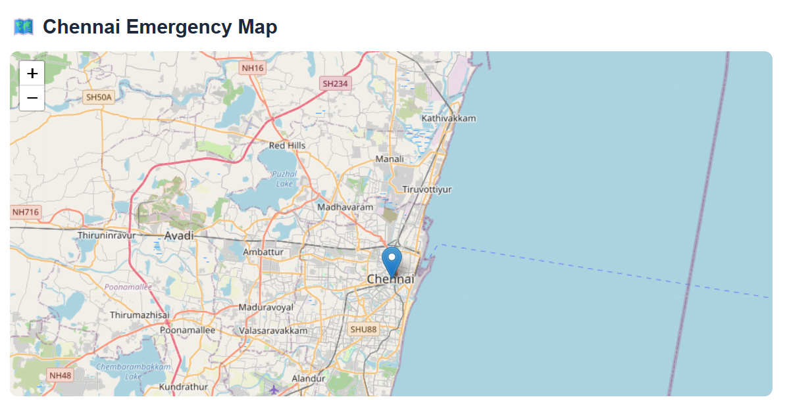Fig 1: map
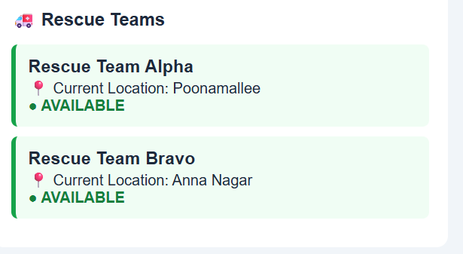 Fig 2: rescue area

4.5 Data Analysis & Engineering Judgment
The system was evaluated using request priority, team availability and route calculation. Higher-priority requests were placed before lower-priority requests. Dijkstra provided the shortest path based on the graph weights. GPS and network availability remain important factors for real-time operation

4.6 Comparison with Existing Solutions & Achievement of Objectives
Table:12
Objective | Evidence | Achievement  (Fully/Partially/Not  Achieved)
Admin Dashboard | Working Dashboard | Fully
Emergency Map | Location Markers | Fully
Priority Handling | Priority Markers | Fully
Team Assignment | Available Team Selection | Fully
Shortest Route | Dijkstra Output | Fully

4.7 Strengths & Limitations
Strengths
- Priority-based emergency handling
- Interactive location map
- Shortest-path route calculation
- Simple web interface
- Database-based storage
Limitations
- Requires internet/GPS availability.
- Route accuracy depends on available map data.
- No live traffic prediction.
- Large-scale deployment needs stronger infrastructure.

4.8 Project Planning, Roles & Budget
Milestones
Requirement Analysis → UI Design → Database → Flask Development → Algorithms → Integration → Testing → Final Demo
Table:13
Student | Assigned Responsibility | Actual Contribution
Student 1 | User module | Registration and GPS
Student 2 | Stranger module | Report and photo
Student 3 | Admin module | Map, queue, graph & dijkstra
Item | Estimated Cost | Actual Cost
Python/Flak | ₹0 | ₹0
VS Code | ₹0 | ₹0
SQLite | ₹0 | ₹0
Map Tools | ₹0 | ₹0
Total | ₹0 | ₹0

5
CONCLUSION, FUTURE WORK AND REFLECTION

5.1 Conclusion
The proposed Disaster Relief Resource Allocation System provides a web-based method for managing emergency requests. It combines an interactive map, Priority Queue and Dijkstra algorithm to support faster request prioritization, rescue-team assignment and route selection.

5.2 Future Work
In the future, the system can be improved by adding real-time rescue team tracking, live traffic-based route updates, SMS or notification alerts, and a mobile application. AI-based priority prediction can also be added to identify critical emergency requests more accurately. The system can further be enhanced to support multiple disaster locations and larger numbers of users.

5.3 Professional Learning & Individual Reflection
New Knowledge Acquired
- Flask web development
- Interactive map integration
- Priority Queue implementation
- Graph and Dijkstra algorithm
Engineering & Professional Skills Developed
- Problem solving
- Database handling
- Web development
- Team collaboration
- Testing and debugging
Individual Reflection – Student 3
- Difficult Problem: Integrating map locations with rescue management was challenging. It was solved by connecting the map with the Flask backend.
- Engineering Decision: Priority Queue was selected because emergency cases should not be handled only by arrival order.
- New Knowledge: Learned Flask, interactive maps and Dijkstra implementation.
- Redesign: Live traffic and real-time team tracking would be added in a future version.

REFERENCES
REFERENCES
- International Organization for Standardization and International Electrotechnical Commission, ISO/IEC 25010:2023 – Systems and Software Engineering – Systems and Software Quality Requirements and Evaluation (SQuaRE) – Product Quality Model, Geneva, Switzerland: ISO, 2023.
- World Wide Web Consortium (W3C), Web Content Accessibility Guidelines (WCAG) 2.2, W3C Recommendation, Oct. 2023. W3C WCAG 2.2
- OWASP Foundation, Application Security Verification Standard 4.0.3, OWASP, 2021. OWASP Application Security Verification Standard
- Python Software Foundation, Python 3 Documentation, Python Software Foundation. Python Documentation
- Pallets, Flask Documentation, Pallets Projects. Flask Documentation
- V. Agafonkin, Leaflet – JavaScript Library for Interactive Maps, Leaflet. Leaflet Documentation
- OpenStreetMap Foundation, OpenStreetMap Wiki and Documentation, OpenStreetMap. OpenStreetMap Documentation
- SQLite Consortium, SQLite Documentation, SQLite. SQLite Documentation
- Open Source Geospatial Foundation, OpenStreetMap and Open-Source Geospatial Resources, Open Source Geospatial Foundation. OSGeo Foundation
- OpenAI, ChatGPT, OpenAI, 2026. AI-assisted resource used for project documentation support, idea development, and language refinement. OpenAI

APPENDICES
Appendix A – Detailed Calculations
This appendix contains the important calculations used in the Admin/Rescue Management module.
- Priority Queue calculation showing how emergency requests are arranged based on severity.
- Graph edge-weight calculation representing distances between locations.
- Dijkstra calculation showing the shortest route from the rescue team to the affected location.
- Example route and total distance obtained from the algorithm.
Example:
If three requests have priorities Critical, High and Medium, the Priority Queue processes them in the order:
Critical → High → Medium
For routing, Dijkstra's algorithm compares the available graph paths and selects the path with the minimum total distance.

Appendix B – Engineering Drawings / Schematics
The following diagrams are included:
- Overall System Architecture Diagram
- Admin Module Flowchart
- Priority Queue Flowchart
- Graph and Dijkstra Flowchart
- Database Structure / ER Diagram
- Admin Dashboard and Map Design
These diagrams show the interaction between affected persons, helpers, Flask application, database, admin, rescue teams and routing algorithms.

Appendix C – Source Code / Code Repository Information
Only the essential source-code excerpts are included in the report. The complete source code is maintained separately.
Main implementation files:
- app.py – Flask backend and application routes
- index.html – Main interface
- admin.html – Admin dashboard
- style.css – User interface styling
- script.js – Client-side functions
- database.db – SQLite database
- Priority Queue implementation
- Graph and Dijkstra implementation
Screenshots of important code sections may be included where required.

Appendix D – Datasheets
Not Applicable.
The proposed system is a software-based web application and does not use physical electronic components or hardware requiring manufacturer datasheets.

Appendix E – Experimental / Raw Data
The following test data are maintained for system evaluation:
- Emergency request details
- Emergency priority levels
- Affected-person locations
- Stranger/helper reports
- Rescue-team availability
- Graph nodes and edge distances
- Dijkstra route results
- Priority Queue processing results
- System response-time observations
Sample test records may be included as tables or screenshots.

Appendix F – Ethics / Institutional Approval
Not Applicable, unless required by the institution.
The project uses limited emergency-related information for demonstration and testing. Location information is intended to be accessible only to authorized rescue/admin users, and unnecessary personal information is avoided.

Appendix G – Project Meeting / Progress Records
This appendix contains evidence of project progress, including:
- Team meeting records
- Supervisor discussions
- Task allocation
- Development progress
- Testing discussions
- Module integration
- Final review and demonstration
Screenshots of meetings, progress updates or supervisor reviews may be attached.

Appendix H – User / Industry Feedback
Where applicable.
Feedback may include comments from project reviewers, students, faculty members or potential users regarding:
- Ease of use
- Admin dashboard
- Emergency prioritization
- Map functionality
- Rescue-team assignment
- Route calculation
If no formal feedback was collected, this appendix can be marked Not Applicable.

Appendix I – Publications / Patents / Competitions / Product Outcomes
Not Applicable, if no publication, patent, competition or product outcome is associated with the project.
If the project is submitted to a competition, published, demonstrated externally or developed into a product, supporting certificates or evidence may be included here.

Appendix J – Individual Contribution Evidence
Student 3 – Admin / Rescue Management Module
The individual contribution included:
- Designed and developed the Admin/Rescue Management module.
- Developed the Admin Login and Dashboard.
- Integrated the interactive map for displaying affected-person locations.
- Implemented Priority Queue for emergency request prioritization.
- Implemented Graph and Dijkstra algorithm for shortest-route calculation.
- Developed rescue-team assignment and status update functions.
- Tested map, priority, routing and database functions.
- Participated in system integration and debugging using VS Code.
Fig 3:dash board
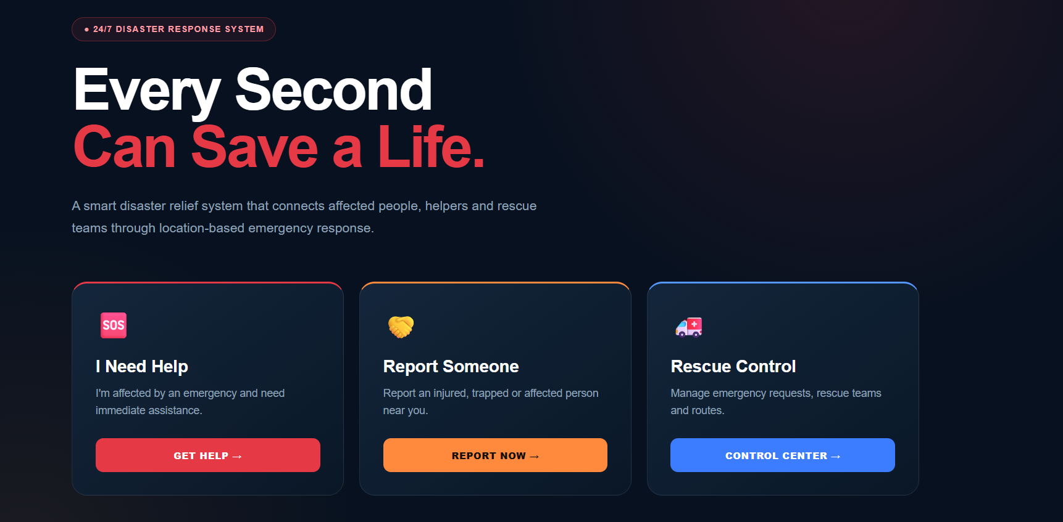

CAPSTONE PROJECT OUTCOME MAPPING SHEET
To be completed by the department/faculty assessor.
Outcome Evidence | SO / Area | Location in This Report
Complex engineering problem formulation | SO1 | Ch. 1, Ch. 2
Engineering design under constraints | SO2 | Ch. 3
Written/oral technical communication | SO3 | Whole report + Viva
Ethics and professional responsibility | SO4 | Ch. 3 (3.7)
Teamwork and leadership | SO5 | Ch. 4 (4.8)
Experimentation, analysis, engineering judgment | SO6 | Ch. 4 (4.3–4.6)
Independent acquisition of new knowledge | SO7 | Ch. 5 (5.3)
Standards | SO2 | Ch. 3 (3.2)
Sustainability and  societal/environmental impact | SO2/SO4 | Ch. 3 (3.7)
Risk assessment and mitigation | SO2/SO4 | Ch. 3 (3.7)
Security considerations | Relevant SO | Ch. 3 (3.7)
Integrated/system-level engineering | SO1/SO2 | Ch. 3 (3.5)
Project planning and management | SO5 | Ch. 4 (4.8)
Individual contribution | SO1–SO7 | Contribution Statement + Ch. 4  (4.8)

